School Council Meeting Oct. 28th, 2019
School Council Members Present: Cynthia Winter, Clay’s principal, Angela Whitehead, Harmony Leland’s principal, Kevin O’Meara, Melody Cruell, Tammy Floyd, Stem teacher, Loutina Murrell, Melody Cruell, Laura Zhiss, Michela Moore, Keisha Clark, Lauline Babino, Michelle Kirk, Nate Smith, Ericka Graham, Marquita Jackson, Javious Canty, Ronda Shepard, Kathryn Starowicz, Donna Brown
Meeting called to order at: 3:35 pm
- Welcome and Introductions
- New Business:
  - School Council Video
  - Review/update Bylaws
    - Six meetings a year
    - Overview of duties of Officers
    - Parliamentary Procedures
    - Article V: Membership, number three will be looked at to be grammatically corrected. As well as correction to #1. “Two Parents or guardians” to “Four Parents or guardians”, in addition to #2. Where “Two Parents who are businesspersons” #3. Parents must be the majority members (6 parents). #4. Certified teachers … #5. The school Principal.
    - Article IX: Meetings: Second Paragraph “notice by mail” to notice by email.
    - Overall: Change the name of the school to the New merger name.
    - Concern over when the Members would turn over. With additional concerns for the following year being combined into one school. Members will serve two years and would need to be elected again to stay on the council. Will there be a transition period for the councils to discuss the “hand-off”.
    - Looking into the Bylaws for this current year.
    - Nominations will change to One year serving.
  - Nominations
    - Chairperson: Mrs. Kirk nominates Laura Zhiss. Rhoda Sheppard 2nds nomination.
    - Co-Chairperson: Kesha Clark Nominated by Canty.
    - Secretary: Nominated Mrs. Star by Mrs. Zhiss
    - Parliamentarian: Nominated Mrs. Kirk
  - Calendar
    - Future meetings will be held at 3:30 on the following days and locations:
      - Nov. 11th at Harmony, Dec. 9th at Clay, Jan.13th at Harmony, Feb. 10th at Clay, March 9th at Harmony, April 13th at Clay.
      - Secretary will Post Meeting dates one week prior at both schools.
  - School Data
    - Review both schools Demographics.
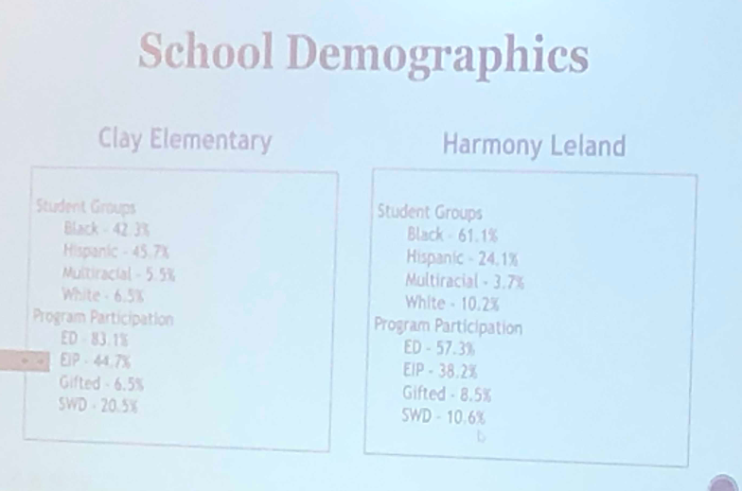
- The new school will Not eligible for School Choice for the first three years.
- CCRPI Scores:
  - Clay Elementary shares the growth in all areas and proud to share that we have a steady growth from a 59.2 in 2015 to a 74.8 in 2019. Proud of our Progress area that continues to grow and focusing on all student groups to ensure all students are growing (below, on, above level).
  - Harmony Leland is proud of going from a 67.0 in 2018 to a 73.5 in 2019. Harmony Leland is especially proud of closing the Gap 55.8 points and will continue to increase student performance in the years to come. Closing gaps between different groups of students. Very intentional about targeting additional support with students.
  - Upcoming school year, our scores should be coming back to us as one school. We are doing the same types of programs with each school.
  - Overall both schools have very similar scores.

To view CCRPI scores
www.gadoe.org
-Data and Reporting
-College and Career Ready
Performance Index
View 2019 CCRPI reports here
New School Name: Clay-Harmony Leland

  - Goals for 2019-2020
    - Mascot, Colors- Department in the County works on the brand.
    - Brainstormed ideas for the Organization for the upcoming meetings.
      - Class size
      - Specials with possible addition of STEM or computers. (Noted that comes out of teacher allotments.)
      - After school programs, school sponsored vs. bring in outside vendors.
      - Before and after school programs
      - 5th grade field trip
      - Uniforms
      - Bilingual office
      - Use of rotating for compacting purposes
      - Cluster of School Councils Collaboration to work together through Middle and High. Vertical Collaboration
      - An open to the public/ribbon cutting for a tour of the new school.
      - Looking into the high schoolers and outside community for tutoring purposes.
      - Community Partnerships between the two schools, merging. (Churches, volunteers, etc.)
        - Flyer (once branded) to give to new partnerships.
Open discussion:
- Class sizes for the upcoming school year. Discussion on Reduced Class Models and how that will affect the new year. Discussion on how FTE works for the county.

- PTA- merging events. Fall Festival will be held at Harmony Leland. Spring Festival will be held at Clay. Looking into a formal PTA or Foundation for fundraising purposes. Officers will be meeting to discuss what will each school be bringing into the merger of the two schools. Noted that Foundation and PTA are separate identities. Both PTA and Foundation should look into for the transition plan, so parents/families are primed to help the schools. The delivery of communication of how we need funds. Half the battle is getting the information out there for the families to plan for the who, what and when. Suggestion to offer PTA packages. Setting and advertising financial goals from parents and community partnerships. We need to be mindful of Intentional fundraising, not to nickel and dime our families.

- Options for what is needed at both schools. Fieldtrips and funding.

- Looking into the time for the meetings.

Next Meeting is: Dec. 9th at 3:30 at Harmony Leland
Meeting ended at 5:04 pm.

