How to Create a MyPaymentsPlus Account
Go to www.MyPaymentsPlus.com
- Click Here:

Step 1: Add your student/patron to the account.
- Select your state and school/school district from the dropdowns.
- Next, you will see the box below. Please select “I have a student enrolled or I am a staff member of this district.” (If you are the student, the same directions apply.)
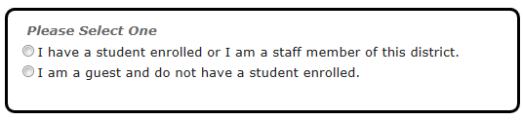
- Enter your child’s student ID number and last name (if you are the student, please enter your information).
- Student ID numbers may usually be obtained by contacting your student’s school.
- If your child’s last name has a suffix, please keep this in mind when entering the last name.
Ex. “Smith Jr.” “Smith IV” “Smith‐Arnold”
- Select:
If you wish to add another student, repeat step 1.
- Select:
Step 2: Create your profile.
- Enter your name, address, and phone number.
- Enter an active e‐mail address. It’s important to enter a correct address so that you can receive e‐mail reminders, username/password information, and payment confirmations.
- Select:
Step 3: Create your sign‐in.
- Choose a “Username” that will be easy for you to remember.
- Enter a 7‐20 character password. Keep in mind that your password is case sensitive. (1 number and 1 letter required).
- Enter a password hint to help you remember your password.
- Select:
Step 4: Confirm your profile.
- Verify that all information you entered is correct.
- If you need to change any of the information, you can click on the Edit link next to each section title.
- Select:
Step 5: Your registration is complete!

